The debate of the most beautiful woman in the world

The debate of the most beautiful woman in the world has a long history. In ancient China, there were four women famous for their appearance, Xishi, Wang Zhaojun, Diao Chang and Yang Yuhuan. In the modern world, Marilyn Monroe represents beauty in 1960’s America. However, our beauty standard varies through ages, different cultures, religions and areas. Despite different attitudes toward beauty, for example, some believe that slim women look better than plump women whereas others prefer plump women for they are they are more suitable in bearing children, the conclusion of beauty remains mysterized until recently scientists found a woman, who is 98% similar to the so-called most beautiful woman.

Those scientists did research in compiling different components of women’s body, trying to find the best points and then sum them up. The first step is to list points on women as much as possible: face, hands, arms, legs, and feet… Under these large categories, there are many miscellaneous items, the color of hair, single-fold eyelid or double-fold eyelid, the ratio of head to body, symmetry or asymmetry. In order to simplify the process, scientist set up some general rules, such as the ratio of head to body should be around to 1 to 9, not too high or too low because this rule had been accepted by most of people. Other rules, such as the waist hip ratio of women should be smaller than 0.8 and breast waist hip ratio should be around 3:2:3. For example, they gathered the pictures of models from different countries and observed them.

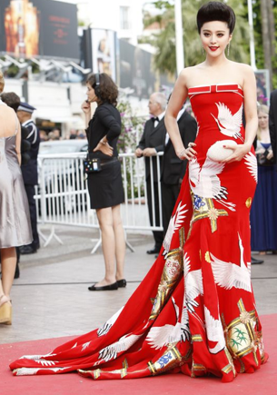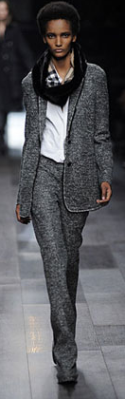

These are pictures depicting three models from different areas, Asia, North America and Africa. We could easily find out that the ratio of their legs to bodies is around 6 to 10. This golden rule is widely applied in the beauty. Below is graph 1.

The golden rule in different areas

|  |  |  |  |  |  |
| --- | --- | --- | --- | --- | --- |
|  | Asian Women | European Women | African Women | North American Women | South American Women |
| Models | 0.573 | 0.593 | 0.583 | 0.611 | 0.601 |
| Actress | 0.593 | 0.579 | 0.621 | 0.622 | 0.621 |
| Singers | 0.577 | 0.587 | 0.596 | 0.612 | 0.632 |

This table is based on numbers that scientists get from five states. Notice that this table supports the golden rule. Most models, actresses, and singers must be very good looking and they share the same legs to bodies ratio (0.6).

The most difficult part of the study is to find a beautiful face. The scale of eyes, nose, ears, mouth of women face is hard to define. Therefore, scientists sent out 100,000 questionnaires to more than 100 countries all around the world and got 925,384 valid copies back. They also used 3D software to draw different faces and presented them on the front page of facebook, asking people to vote for the most beautiful woman. People who were attracted by these images on TV channel e-mailed tons of pictures. Overall, they received 823,679 e-mails, including 839,365 pictures. By analyzing tons of information, they tabulated the result in the table below.

|  |  |  |  |  |  |
| --- | --- | --- | --- | --- | --- |
|  | Distance between eyes | Tall or low nose | Double lid or single lid eye | Curly or straight hair | Distance between eyes and jaw |
| Asian | 2.82cm | 3cm | Double | Straight | 10.8cm |
| European | 2.91cm | 2.97cm | Double | Curly | 11cm |
| African | 2.78cm | 2.89cm | Single | Curly | 11.2cm |
| North American | 2.84cm | 3.11cm | Single | Curly | 10.9cm |
| South American | 2.86cm | 3.08cm | Double | Curly | 11.1cm |

This table gives us a clue of people’s perception of the most beautiful woman in the world. If we combine these traits together and divide them by 5, then we could probably find the most beautiful woman. Say, take distance between eyes as an example; (2.82+2.91+2.78+2.84+2.86)/5=2.842cm. So we know that the most beautiful woman in the world must have eyes-between distance around 2.842cm.

They did a lot of preliminary work like above and finally began their building process, creating the model of the most beautiful woman, calling her “THE”. THE has a round face, S-shape body and long hair. However, they could not find anyone who had the same feature of THE since it does not exist.

After the result of THE was published, Barack Obama commented on the New York Times, “This is the most absurd experiment ever done for I personally believe THE is fairly normal in appearance.” To refute Obama’s words, scientists began to design another questionnaire and disappointingly found out that THE was not charming at all. Statistics show that 86% of people prefer Mrilyn Monroe while only 59% like THE [3]. Longhao Chen, a professor who teaches human biology as well as psychology at Hampshire College, explained this phenomenon “People’s perception toward beautiful woman varies in terms of familiarity. They always prefer whom they know well when they cannot decide who looks more beautiful. THE is such a weird model while Marilyn Monroe used to stand beside John F. Kennedy.” Scientist Ben Liebman, who participated in the experiment, explained, “It is very hard to build a perfect woman but we have tried our best. We need to consider values in different cultures, countries, societies, which makes this experiment almost impossible to finish.”

Throughout this project, scientists have found the prototype of THE, but the question is “Where is it?”

How I revise this essay

Basically, I do not change a lot about it. I correct some words and grammar errors. I combine “naysayers’” paragraphs into one paragraph.