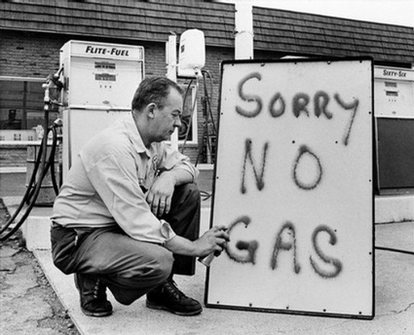

Come and hug the third generation of solar panels with the highest 80% transmission rate.

With the invention of the third generation of solar panels in the past few years, we have come to an age of solar energy. No need to pay for gas money, you just need to install a solar panel and drive your car to anywhere.

Still annoyed by the shortage of oil?

\*